**BUS RESERVATION SYSTEM**



**Introduction:**

The focus of the project is to computerize traveling company to manage data, so that all the transactions become fast and there should not be any error in transaction like calculation mistake, bill generation and other things. It replaces all the paper work. It keeps records of all bills also, giving to ensure 100% successful implementation of the computerized Bus reservation system.

This reservation system has three modules. First module helps the customer to enquire the availability of seats in a particular bus at particular date. Second module helps him to reserve a ticket. Using third module he can cancel a reserved ticket.

First module retrieves data from tables required for enquire.

Second module inserts values into the tables on reservation.

Third module deletes values into from the table on cancellation of tickets.

As the database is hosted using Oracle Server onto internet, the application can access data from any part of the world, by many number of people concurrently.

**PROBLEM SPECIFICATION:**

Bus Reservation Systems that were suggested till now, are not up to the desired level. There is no single system which automates all the process.

In order to build the system, all the processes in the business should be studied; System study helps us under the problem and needs of the application. System study aims at establishing requests for the system to be acquired, development and installed. It involves studying and analyzing the ways of an organization currently processing the data to produce information. Analyzing the problem thoroughly forms the vital part of the system study. In system analysis, prevailing situation of problem is carefully examined by breaking them into sub problems. Problematic areas are identified and information is collected. Data gathering is essential to any analysis of requests. It is necessary that this analysis familiarizes the designer with objectives, activities and the function of the organization in which the system is to be implemented.

**Existing system**

✓Existing system is totally on book and thus a great amount of manual work has to be done. The amount of manual work increases exponentially with increase in services.

✓Needs a lot of working staff and extra attention on all the records.

✓In existing system, there are various problems like keeping records of items, seats available, prices of per/seat and fixing bill generation on each bill.

✓Finding out details regarding any information is very difficult, as the user has to go through all the books manually.

✓Major problem was lack of security.

1. **Proposed system**

The system is very simple in design and to implement. The system requires very low system resources and the system will work in almost all configurations. It has got following features:

✓Needs a lot of working staff and extra attention on all the records.

✓Ensure data accuracy.

✓Records are efficiently maintained by DBMS.

✓DBMS also provides security for the information.

✓Any person across the world, having internet can access this service.

✓Availability of seats can be enquired very easily.

✓Passengers can also cancel their tickets easily.

✓Minimum time needed for the various processing

✓Better Service

✓Minimum time required

✓This would help the corporation prepare and organize its schedules more efficiently on the basis of traffic demand.

**SOFTWARE REQUIREMENT SPECIFICATION**

**Hardware Requirements:**

PC with Pentium IV processor.

512 MB RAM or above.

40 GB Hard Disk or above.

**Software Requirements:**

Operating system : Windows XP (or latest).

Front end : Java Runtime

Platform : Java Swings

Integrated development environment(IDE) : Eclipse

Back end : Oracle 10g

**Database design:**

|  |
| --- |
| **BUS DETAILS** |
| Bus Name |
| Total Seats |
| Reserved Seats |

|  |
| --- |
| **Reservation Status** |
| Bus Name |
| Seat Id |
| Reserved |
| Customer Name |

**Schema:**

>>>>>>>>>>>>>>>>>>>>CREATE TABLE<<<<<<<<<<<<<<<<<<<<

create table bus_details(bus_name char(15) primary key,total_seats number(3),reserved_seats number(3));

create table busreservation_status(bus_name char(15) references bus_details(bus_name),seat_id number(3),reserved char(2) check (reserved in('y','n')),customer_name char(15));

>>>>>>>>>>>>>>>>>>>>ENTER BUS DETAILS<<<<<<<<<<<<<<<<<<<<

declare

bname char(15);

tot number(3);

resv number(3);

cursor cur is select * from bus_details;

begin

insert into bus_details values('&bus_name',&total_seats,0);

open cur;

loop

fetch cur into bname,tot,resv;

if cur%found then

for i in 1..tot

loop

insert into busreservation_status values(bname,i,'n',null);

end loop;

else

exit;

end if;

end loop;

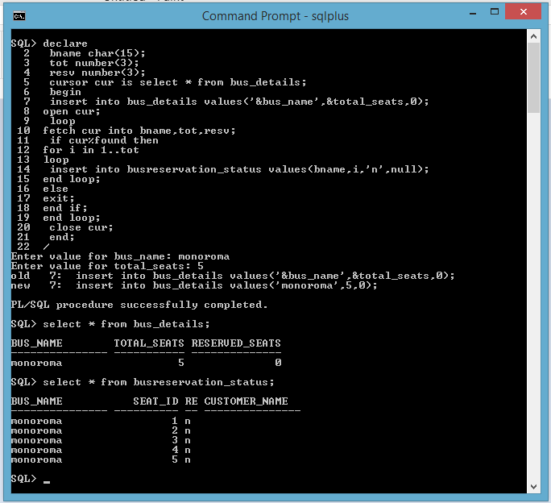 close cur;

end;

/

>>>>>>>>>>>>>>>>>>>>BUS RESERVATION<<<<<<<<<<<<<<<<<<<<

declare

cname char(15);

bname char(15);

sid number(3);

tot number(3);

resv number(3);

begin

cname:='&cname';

bname:='&bname';

select total_seats into tot from bus_details where bus_name=bname;

select reserved_seats into resv from bus_details where bus_name=bname;

if tot>resv then

select MIN(seat_id) into sid from busreservation_status where bus_name=bname and reserved='n';

update busreservation_status set reserved='y' where bus_name=bname and seat_id=sid;

update busreservation_status set customer_name=cname where bus_name=bname and seat_id=sid;

update bus_details set reserved_seats=reserved_seats+1 where bus_name=bname;

end if;

dbms_output.put_line('No seat avalable');

end;

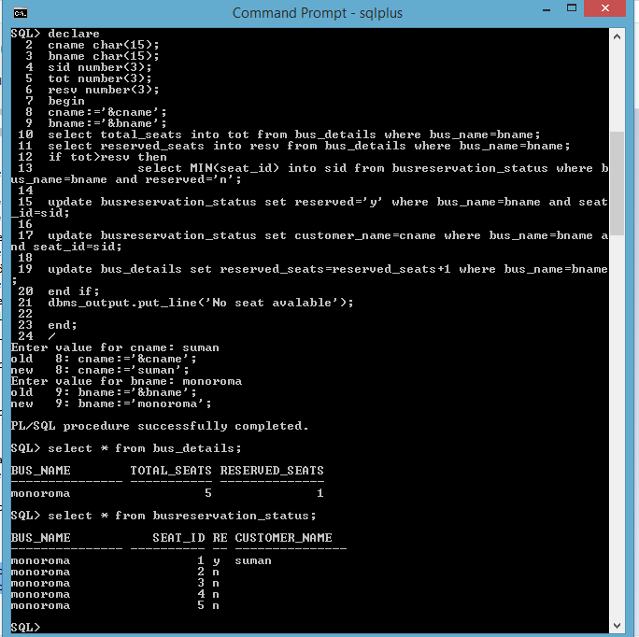/

>>>>>>>>>>>>>>>>>>>>BUS CANCELATION<<<<<<<<<<<<<<<<<<<<

declare

cname char(15);

bname char(15);

sid number(3);

resv number(3);

begin

cname:='&cname';

bname:='&bname';

select seat_id into sid from busreservation_status where bus_name=bname and customer_name=cname;

select reserved_seats into resv from bus_details where bus_name=bname;

if resv<0 then

dbms_output.put_line('Cancelation not allow');

else

update busreservation_status set reserved='n' where bus_name=bname and seat_id=sid;

update busreservation_status set customer_name=null where bus_name=bname and seat_id=sid;

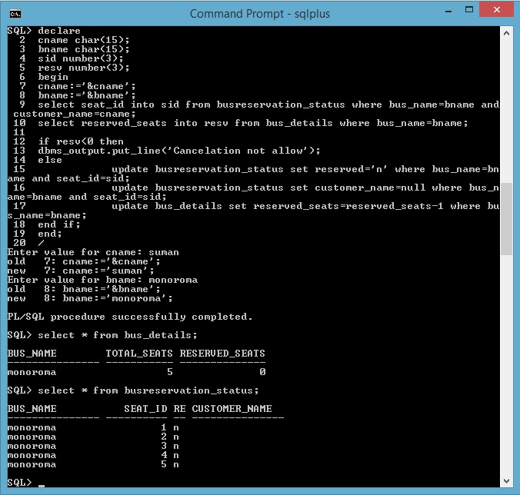 update bus_details set reserved_seats=reserved_seats-1 where bus_name=bname;

end if;

end;

/

**CONCLUSION**

This project is designed to meet the requirements of a Bus reservation system. It has been developed in visual basic and the database has been built in PL/SQL only, keeping in mind the specifications of the system. Apart from MS-Access we could have also implemented other database software like Oracle or SQL. For designing the system we have used simple data flow diagrams and E/R diagrams. Overall the project teaches us the essential skills like:

1. Using system analysis and design techniques like data flow diagram and E/R diagram in designing the system.

2. Understanding programming logic and language along with utilities like reports, forms, queries etc. in Visual Basic and PL/SQL.

**References:**